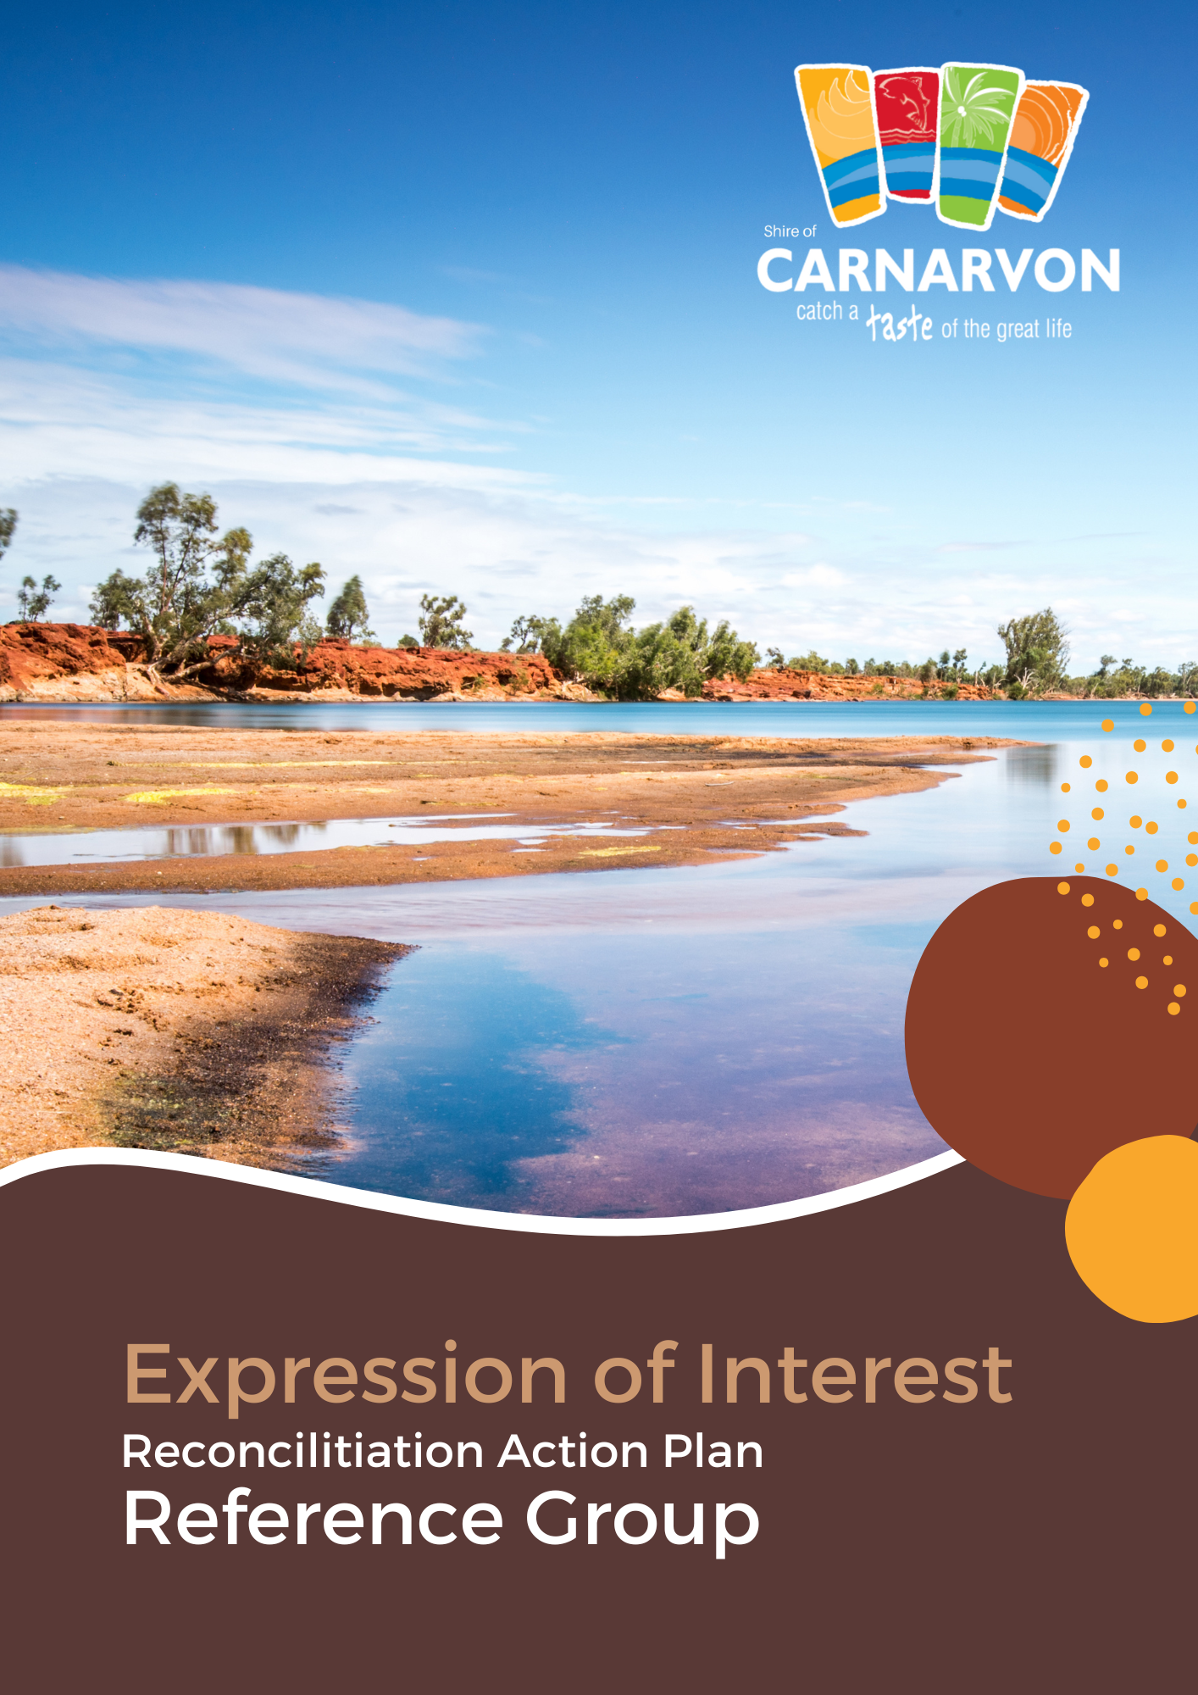

The Shire of Carnarvon is seeking nominations from interested persons in our community to become members of the Reconciliation Action Plan Reference Group.
The Reconciliation Action Plan Reference Group (Up to 5 Community/ Stakeholder Representatives) is vital in guiding the Shire of Carnarvon's ongoing journey towards reconciliation.
The RAP Reference Group’s purpose is to provide the Shire of Carnarvon with strategic advice on Aboriginal people's views, needs and interests in the Carnarvon region.
The RAP Reference Group will inform and monitor the Shire of Carnarvon’s Reconciliation Action Plan implementation through collaboration, communication, and positive relationships.
Expressions of Interest (EOI)
An internal selection panel of Council Officers will consider expressions of Interest. All appointments will be determined by Council resolution.
EOI opens: Wednesday, 24 May 2023
EOI closes: Wednesday, 14 June 2023
To nominate, please complete the nomination form below.
Note: Prospective nominees must ensure they have read and agree to the Terms of Reference before applying. The Terms of Reference are provided with this nomination form.
For further information, please contact the Shire of Carnarvon on (08) 9941 0000 or via email at shire@carnarvon.wa.gov.au

Nomination Form
Your Details
Note: Note: This information will be treated as confidential and will not be published in any document or report on the outcomes of the consultation.
Name:
Address:
Suburb:
Phone:
Mobile:
Email:
Gender: ☐ Male ☐ Female ☐ Other
Nomination
☐ A community representative
☐ An organisational representative
* If nominating as an organisational representative, please confirm the organisation, group or business you will be representing: ____________________________________________________
☐I confirm I have approval from this organisation to be its representative on the RAPRG.
☐I have read, understood and agreed to the Terms of Reference associated with the Reconciliation Action Plan Community Reference Group.
Selection Criteria
Please complete the selection criteria below to outline your interest and suitability to become a member of the Reconciliation Action Plan Reference Group. Maximum of 300 words per question.
Why are you interested in the Shire of Carnarvon’s Reconciliation Action Plan?
Please advise of any relevant connection, experience, or knowledge to support your nomination to the Shire of Carnarvon’s Reconciliation Action Plan Reference Group.
Why do you believe you are suitable for a Reconciliation Action Plan Reference Group position?

Please submit your nomination form by the closing date of Wednesday, 14 June 2023 at 4pm
For further information, please contact the Shire of Carnarvon on (08) 9941 0000 or via email at shire@carnarvon.wa.gov.au
Thank you for nominating for the Reconciliation Action Plan Community Reference Group.

