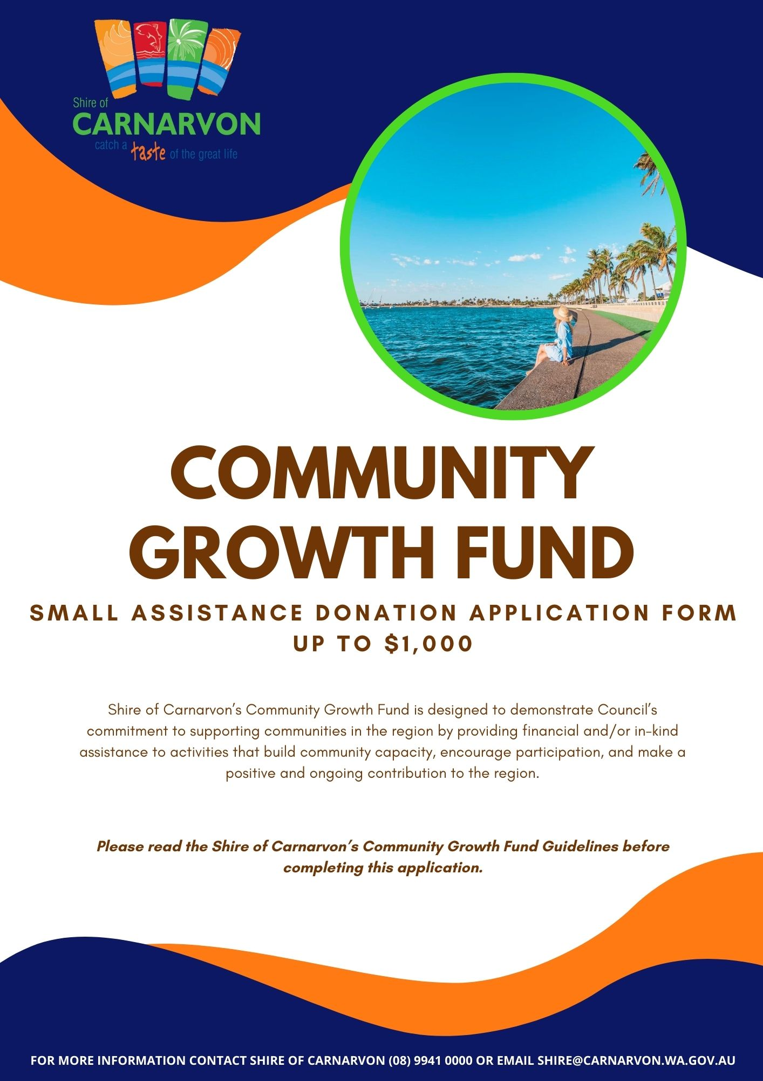

Q1. Details of your Organisation

Organisation: _________________________________________________________________

Street Address: ________________________________________________________________

Suburb: _________________ State: _________________ Postcode: _________________

Postal Address: ________________________________________________________________

Suburb: _________________ State: _________________ Postcode: _________________

Contact number: ________________ Email: ______________________________________

Q2. Contact Person

Name: ___________________________ Position: _____________________________

Contact number: ________________ Email: ______________________________________

Q3. Type of Organisation

☐ Not for profit organisation ☐ Incorporated organisation

Q4. Does your Organisation have an Australian Business Number (ABN)?

☐ Yes ☐ No

Q5. Is your Organisation registered for GST?

☐ Yes ☐ No

Q6. Does your Organisation have Public Liability Insurance?

☐ Yes ☐ No or ☐ N/A

Amount Insured: _____________________

Grant History

Q7. Has the Organisation previously received a Community Growth Fund Grant with the Shire of Carnarvon?

☐ Yes ☐ No

If yes, please provide details below and has this grant been acquitted?

Project Name | Amount | Year Funded

Grant Details

Q8. What category does your application fit within:

☐ Operational (e.g. are you requesting financial assistance for a rates notice)
☐ Event (e.g. is your application for an event/activity)
☐ Project (e.g. is your application for a development project/infrastructure etc.)
☐ In-Kind (e.g. hire/usage of Shire facilities or assets)

Q9. Funding amount requested (ex. GST) $______________________

Q10. Have you spoken with the Community Development Officer in relation to this application?

☐ Yes ☐ No

Q11. How will Shire of Carnarvon be recognized for its support?

☐ Council banners ☐ Logo on website
☐ MC announcements ☐ Radio/ television
☐ Keynote speeches ☐ Logo on advertising materials
☐ Social media ☐ Other (please specify) ______________________________

Shire of Carnarvon Facebook: @ShireofCarnarvon

Project Details

Q12. Project Name: ___________________________________________________________________

Q13. Project start date _ _ / _ _ / _ _ _ _ Project end date _ _ / _ _ / _ _ _ _

Q14. Is this event/ project/ activity a ☐ one-off or ☐ recurrent? (If applicable)

Q15. Detailed project description (100 words or less):

____________________________________________________________________

___________________________________________________________________________________

___________________________________________________________________________________

___________________________________________________________________________________

___________________________________________________________________________________

___________________________________________________________________________________

___________________________________________________________________________________

___________________________________________________________________________________

___________________________________________________________________________________

Q16. Select the demographics this project will target:

☐ Men ☐ Women
☐ Family ☐ Tourists
☐ Children aged 0-11 yrs ☐ Young people aged 12-25 yrs
☐ Aboriginal or Torres Strait Islander peoples ☐ People with disability/ special need
☐ Other (please specify) ________________________________________________________

Q17. Number of participants/ attendees expected (if applicable): ______________

Q18. Ticket fee (if applicable) $_____________

Q19. Describe in 100 words or less how the project provides a direct or indirect benefit, including social and economic, for the community. These should be measurable and achievable.

____________________________________________________________________

___________________________________________________________________________________

___________________________________________________________________________________

___________________________________________________________________________________

___________________________________________________________________________________

___________________________________________________________________________________

___________________________________________________________________________________

___________________________________________________________________________________

Q20. In 100 words or less, what is the main reason you are applying for this funding and how does it meet a need in the community?

____________________________________________________________________

___________________________________________________________________________________

___________________________________________________________________________________

___________________________________________________________________________________

___________________________________________________________________________________

___________________________________________________________________________________

___________________________________________________________________________________

Q21. Will this project go ahead without Council’s funding?

☐ Yes ☐ No

Q22. Please attach any letters of support demonstrating the community’s support for your proposed project.

Q23. Demonstrate other financial and/or in-kind contributions/partnerships that will assist in the delivery of this program/project or activity.

Funding Source | Amount

Q24. Choose 1 (one) or more Strategic Community Plan objectives or strategies that your application aligns with, provide a detailed explanation of how it aligns with this objective or strategy.

☐ Economic: A strong and growing economy, with a thriving regional centre, abundant business opportunities and jobs.

☐ Natural and built environment: A sustainable natural and built environment that meets current and future community needs.
☐ Social: Healthy, safe and resilient community, where everyone belongs.

☐ Cross-cultural connection: Acknowledged and celebrated traditional owners and diverse cultures that make up the community.

☐ Civic: Strong and listening Council.

Q25. Detailed Budget – Income and Expenses

- Round all amounts to whole dollars.
- Demonstrate in your budget where your organisation is contributing a financial cost to the project.
- Council reserves the right to request further information on budget items.

*Example of budget table below, please attach yours with application.
Expenses | Cost | SoC Grant
Total Expenses | $ | $
Income (includes in-kind contributions)
Total Income | $ | $

Total Project Cost (this should match total expenses): $_____________________________________

Q26. Application checklist

Please ensure all documents requested are attached with application. Any application that is incomplete and does not have relevant documents attached will not be considered.

☐ Recent financial statement attached
☐ All questions have been answered
☐ Project budget provided
☐ Copy of public liability insurance provided
☐ Appropriate person/s have signed

Certification by organisation:

I, the undersigned, certify that:

- I have read and will abide by the Shire of Carnarvon Community Growth Fund Guidelines.
- I am authorized to make this application on behalf of the organization.
- The information contained in this application is, to the best of your knowledge, true and accurate.
- The information you provide in your grant application will be used by the Shire to process and assess your application. The Shire may contact other funding agencies to verify funding requested from other agencies in support of your project.
- The information may be used by the Shire for the promotion of the Community Growth Fund or the promotion of funding outcomes for projects in Carnarvon.
- Willing to take part in the Shire’s communications and marketing material as requested by Shire staff.
Full name: ____________________________

Position at organisation: ____________________________

Signature: ____________________________

Date: _ _ / _ _ / _ _ _ _

