OFFICE USE
Date rec’d:
File #:
Property #:
Record #:
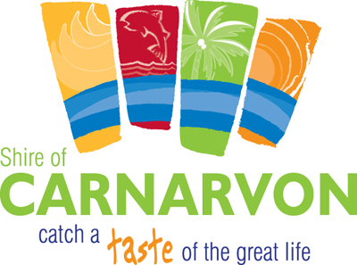
FOOD BUSINESS NOTIFICATION
Food Act 2008, s.107

Business details
Business/trading name:
(This is how your business or stall is known to the customer.)
ABN (if applicable):

Proprietor/operator details
Proprietor/operator name:
(If the business is conducted by an association or incorporated entity, enter the full name of the entity.)
Postal address:
Nominated phone contact:
Nominated email contact:
Other contact (e.g. additional names/numbers/emails):
Name of individual in charge of food handling activities (if different):

Food premises details
Primary food premises address/location/identification:
Other food premises address/location:
(For example, if you propose to prepare or store your food at a different place from where it is sold.)

Food business description
Describe your food business and list your proposed food products and food handling activities:

Events, temporary and periodic food handling
Name of event (if applicable):
Date/s and time/s of operation:
Where will the food be obtained from?
Will food be stored elsewhere before the event?
If yes, describe which food and where.
Will food be prepared elsewhere before the event? If yes, describe which food and where.

For temporary food stalls, describe your proposed stall setup and list your equipment:

Please answer the following questions about your proposed sale of food / food business  In order to be exempt from registration, the answer must be ‘yes’ for each question in at least one exemption category (A, B, C or D). |  |  | Yes | No
A | Is the business conducted to raise money solely for purposes that are of a charitable or community nature? |  | ☐ | ☐
 | If ‘yes’, what is the name of the charity or community group?
 | Are all potentially hazardous foods handled in the business to be cooked for immediate consumption?  Potentially hazardous foods generally include anything that requires refrigeration: meat, egg, dairy and fish products, cut fruit and vegetables (e.g. salads) and cooked grains (rice/pasta etc). Bread, dried or preserved foods and whole fruit and vegetables are not potentially hazardous. Contact an Environmental Health Officer for further clarification. |  | ☐ | ☐
B | Does the business include the handling of non-potentially hazardous foods only? |  | ☐ | ☐
 | If ‘yes’, will the business be dealing with packaged food only? |  | ☐ | ☐
C | Does the food business consist solely of providing complimentary drinks in conjunction with another business that is not a food business? |  | ☐ | ☐
D | Are the food premises a ‘registered establishment’ under the Export Control Act 1982 (Commonwealth), section 3? |  | ☐ | ☐

I, the proprietor of the above-mentioned food business, declare that the information contained in this form is true and correct to the best of my knowledge.

………….................................................................................. …….. / …….. / …….
Signature of proprietor/operator Date

If the proprietor is an incorporated entity, please state the name and position of the person signing:

…………..................................................................................…………..................................................................................
- In Western Australia, any person who sells or handles food for sale is most likely required to notify or be registered with the Local Government of the place where the food is handled, stored or sold. The sale of food includes giving away for promotional purposes, attempting to sell and providing in conjunction with another service. A food business includes any sale of food even if an ABN is not required.
- Horticultural farming does not require notification or registration, except for seed sprout farming and any retail sale of fruit and vegetables, which do require notification or registration.
- All other sale of food—including seed sprout farming, the retail sale of fruit and vegetables, sale of eggs and honey, fundraising sausage sizzles and seafood harvesting and processing—requires ‘notification or registration’ with the local enforcement agency (usually the Local Government).
- Registration—If your business requires ‘notification or registration’ and is not ‘exempt from registration’, then an ‘application for registration of food business’ is required instead of this form.
- When does the notification need to be made? Notification must be made before the commencement of food handling operations. It must also be made prior to any changes being made to an existing business, such as change of operator or contact details, changing the nature of the food business, or changing the location of the food premises.

