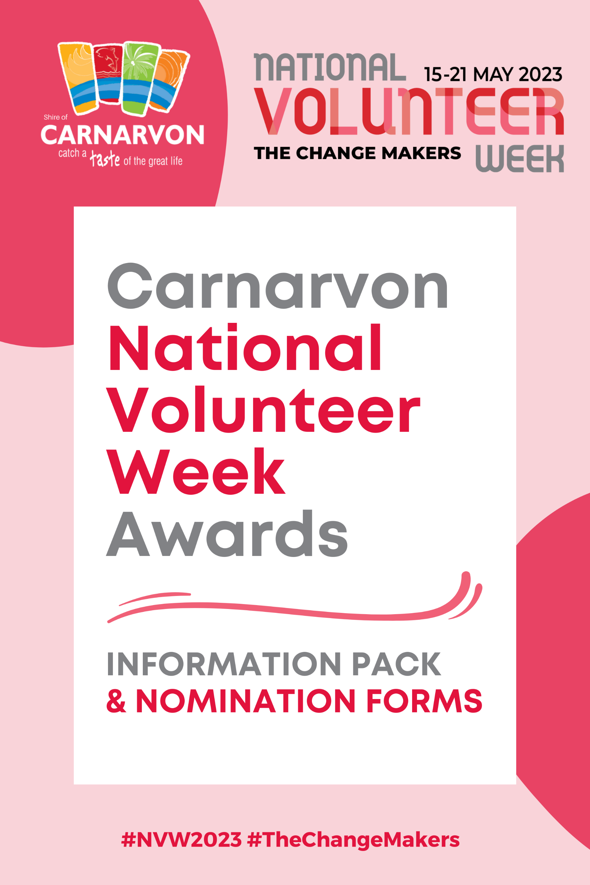
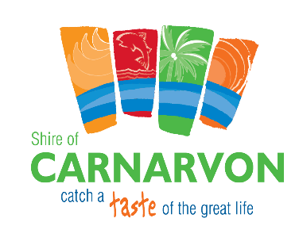

National Volunteer Week is Australia’s largest annual celebration of volunteering and will be held on 15 – 21 May 2023. This year’s theme is The Change Makers.
The week-long event recognises the vital support our country’s millions of volunteers provide to their communities and encourages people to consider volunteering.
National Volunteer Week 2023 is a celebration of our power to drive change and ensure volunteering is inclusive of all members of the Australian community.
Volunteering Australia’s vision for the future will see volunteering thrive. We are the change-makers.
Carnarvon National Volunteer Week Awards
As National Volunteer Week approaches, the Shire of Carnarvon has launched an awards program to recognise and celebrate the incredible contributions of volunteers in our community.
That's why we're excited to announce that the upcoming Carnarvon Volunteer Awards will be held on Wednesday, 17 May, at the Woolshed from 6pm. The evening will include workshops with the Australia Red Cross, a live cross over to Exmouth to meet Carnarvon volunteers with AVIVO, youth First Aid Certificates and recipients of the Carnarvon National Volunteer Week Awards, which will honour outstanding individuals and organisations who have made a positive impact through their volunteer work.
We need the community to help identify those who deserve recognition for their selfless contributions. If you know someone or an organisation that has gone above and beyond to help others, please nominate them for the Carnarvon Volunteer Awards by completing the form below. Nominations closed on Wednesday, 12 April, at 5pm.
Let's come together to celebrate National Volunteer Week and recognise those who have made a difference in our community.
Criteria for Carnarvon National Volunteer Week Awards:
- The nominee must have demonstrated exceptional commitment to volunteering in the Carnarvon community.
- The nominee's volunteering activities should have made a significant positive impact on the community.
- The nominee's volunteering should have been undertaken on a voluntary basis and not for financial gain.
- The nominee's volunteering should have been ongoing and not just for a one-off event.
- The nominee should have demonstrated a positive attitude towards volunteering and be a role model for others in the community.
Categories for Carnarvon National Volunteer Week Awards:
Young 'Change Maker' Volunteer of the Year:
- Must be between the ages of 12-25 years
- Must have made a significant contribution to their community through volunteering
- Must demonstrate leadership qualities and inspire others to volunteer
- Must have volunteered for a minimum of 50 hours in the last 12 months
- Must be able to demonstrate the impact of their volunteering
'Change Maker' Volunteer of the Year:
- Must have made a significant contribution to their community through volunteering
- Must have volunteered for a minimum of 100 hours in the last 12 months
- Must have demonstrated dedication and commitment to their volunteering
- Must be able to demonstrate the impact of their volunteering
- Must have gone above and beyond their duties as a volunteer
Lifetime Contribution to Volunteering:
- Must have made a significant contribution to their community through volunteering over a period of at least 10 years
- Must have demonstrated exceptional commitment and dedication to volunteering
- Must have made a lasting impact on the community through their volunteering
- Must have inspired others to volunteer
- Must be able to demonstrate the impact of their volunteering
Volunteer Group of the Year - Event & Community Organisation:
- Must be a group of volunteers who have made a significant contribution to the community
- Must have worked together effectively and efficiently to achieve their goals
- Must be able to demonstrate the impact of their volunteering on the community
- Must have demonstrated exceptional commitment and dedication to their volunteering
- Must have gone above and beyond their duties as volunteers
How to nominate?
Complete the nomination forms attached to this information pack or visit www.carnarvon.wa.gov.au to complete the forms online. Nominations close Wednesday, 12 April at 5pm. Submissions must be emailed to shire@carnarvon.wa.gov.au.au

What happens next?
- It all starts with your nomination.
- The Shire of Carnarvon Awards Committee will meet on Thursday, 13 April, to review all submissions received and select one recipient in each of the four award categories.
- The recipients will be presented to the Council on Wednesday, 26 April.
- The four recipients are announced on Wednesday, 17 May, at the National Volunteer Week dinner from 6pm at the Woolshed.
More information?
Contact Jennifer Cullen, Community & Cultural Development Officer on (08) 9941 0000 or email Cullen.j@carnarvon.wa.gov.au.

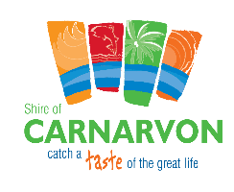
Nomination Form

For categories: Young 'The Change Maker' Volunteer of the Year, 'The Change Maker' Volunteer of the Year and Lifetime Contribution to Volunteering
Your Details
Full Name
Contact Number
Email Address

Who are you nominating?
Full Name
Contact Number
Email Address
What volunteer organisation/s are they part of?

Do you know them personally? ☐Yes ☐ No

What category are you nominating them for?
☐ Young ‘Change Maker’ Volunteer of the Year
☐ ‘The Change Maker’ Volunteer of the Year
☐ Lifetime Contribution to Volunteering
Would you like your nomination to be anonymous?
☐Yes ☐No

Nomination
What motivated the nominee to start volunteering?

What specific volunteering activities has the nominee been involved in?

How has the nominee demonstrated exceptional commitment and dedication to volunteering?

What impact has the nominee's volunteering had on the community?

In what ways has the nominee gone above and beyond their duties as a volunteer?

Submit this Nomination Form
Complete the nomination forms by Wednesday, 12 April at 5pm via email to shire@carnarvon.wa.gov.au or delivering to the Shire of Carnarvon office on Francis Street by 4pm on Wednesday, 12 April.

Nomination Form

For category: Volunteer Group of the Year - Event & Community Organisation
Your Details
Full Name
Contact Number
Email Address

Who are you nominating?
Name of Organisation or Event
Key Contact Person
Email Address
Do you know them personally or part of this organisation? ☐Yes ☐ No

What category are you nominating them for?
☐ Volunteer Group of the Year – Event
☐ Volunteer Group of the Year – Community Organisation
Would you like your nomination to be anonymous?
☐Yes ☐No

Nomination
What motivated the group to start volunteering? If an event, what event or events did the volunteer group organise, and what was their role in it/them?

How did the community organisation or event(s) organised by the volunteer group make a positive impact on the Carnarvon community?

How has the group demonstrated exceptional commitment and dedication to their volunteering or organised event?

What impact has the group's volunteering or event had on the community?

In what ways has the group or event gone above and beyond their duties as volunteers?

Submit this Nomination Form
Complete the nomination forms by Wednesday, 12 April at 5pm via email to shire@carnarvon.wa.gov.au or delivering to the Shire of Carnarvon office on Francis Street by 4pm on Wednesday, 12 April.

