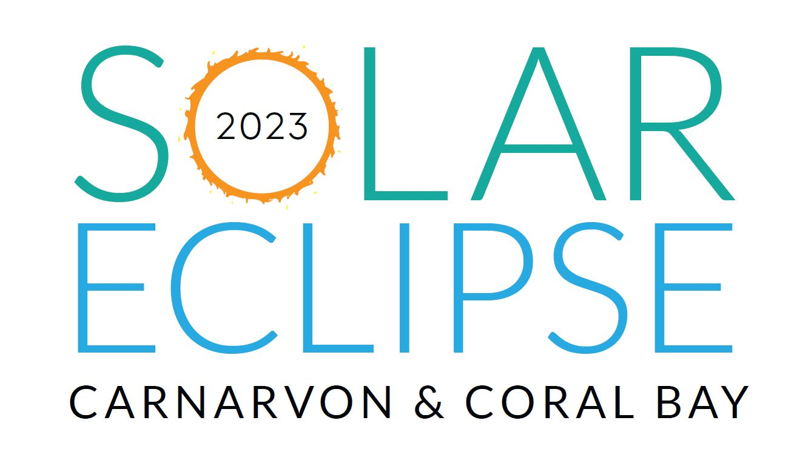
Small Business Participation Grants
Proudly sponsored by the Gascoyne Development Commission
The Shire of Carnarvon invites businesses to apply for financial assistance of up to $1000 for projects which will build business resilience, diversify products and services to meet demand during the TSE and promote the region.
Round opens: 1 January 2023
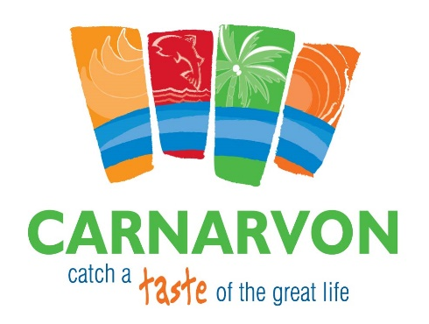
Q1. Details of your business

Name: _________________________________________________________________

Street Address: ________________________________________________________________

Suburb: _________________ State: _________________ Postcode: _________________

Postal Address: ________________________________________________________________

Suburb: _________________ State: _________________ Postcode: _________________

Contact number: ________________ Email: ______________________________________

Q2. Contact Person

Name: ___________________________ Position: _____________________________

Contact number: ________________ Email: ______________________________________

Q3. What is your business Australian Business Number (ABN)?

Q4. Is your business registered for GST?

☐ Yes ☐ No

Q5. Does your business have Public Liability Insurance?

☐ Yes ☐ No or ☐ N/A

Amount Insured: _____________________

Grant Details

Q6. Funding amount requested (ex. GST) $______________________

Q7. Have you spoken with the Shire in relation to this application?

☐ Yes ☐ No

Project Details

Q8. Project Name: ___________________________________________________________________

Q9. Project start date _ _ / _ _ / _ _ _ _ Project end date _ _ / _ _ / _ _ _ _
Note: All projects or activities must be completed prior to/or during the April 2023 WA School Holiday period.

Q10. Detailed project description (100 words or less):

____________________________________________________________________

___________________________________________________________________________________

___________________________________________________________________________________

___________________________________________________________________________________

___________________________________________________________________________________

___________________________________________________________________________________

___________________________________________________________________________________

___________________________________________________________________________________

___________________________________________________________________________________

Q11. In 100 words or less, what is the main reason you are applying for this funding, and how will it help build business resilience, diversify products and services to meet demand or promote the region during the April 2023 Solar Eclipse?

_____________________________________________

___________________________________________________________________________________

___________________________________________________________________________________

___________________________________________________________________________________

___________________________________________________________________________________

___________________________________________________________________________________

___________________________________________________________________________________

Q12. Demonstrate other financial and/or in-kind contributions/partnerships that will assist in the delivery of this project or activity.

Funding Source | Amount

Q13. Detailed Budget – Income and Expenses

- Round all amounts to whole dollars.
- Demonstrate in your budget where your business is contributing a financial cost to the project.
- Council reserves the right to request further information on budget items.

*Example of budget table below, please attach yours with application.
Expenses | Cost | SoC Grant
Total Expenses | $ | $
Income (includes in-kind contributions)
Total Income | $ | $

Total Project Cost (this should match total expenses): $_____________________________________

Q14. Application checklist

Please ensure all documents requested are attached to this application. Any application that is incomplete and does not have relevant attachments will not be assessed.

☐ Recent financial statement attached
☐ All questions have been answered
☐ Project budget provided
☐ Copy of public liability insurance provided
☐ Appropriate person/s have signed

Certification by business:

I, the undersigned, certify that:

- I am authorized to make this application on behalf of the business.
- The information contained in this application is, to the best of your knowledge, true and accurate.
- The information you provide in your grant application will be used by the Shire to process and assess your application.
- Evidence of expenditure and project outcomes will be provided to the Shire of Carnarvon no later than 6 weeks from completion of the project. The project acquittal form is available through Harriet Murphy at murphy.h@carnarvon.wa.gov.au
- The information may be used by the Shire for the promotion TSE or the promotion of funding outcomes for projects in Carnarvon.
Full name: ____________________________

Position at business: ____________________________

Signature: ____________________________

Date: _ _ / _ _ / _ _ _ _

