SHIRE OF CARNARVON
NOTIFICATION OF WORKS
REMOVAL OF COCONUT PALMS
CARNARVON FASCINE

Earlier this year, a mature coconut palm along the Fascine fell to the ground as a result of strong and sustained winds. This occurred in the vicinity of the Carnarvon Hotel on Olivia Terrace. Fortunately no property damage or injury occurred as a result of this incident.

As a result, an inspection of approximately 180 palms and trees along the Fascine was conducted by the Shire.

That inspection identified five (5) coconut palms at risk of similar failure in high winds.

In the interest of public safety, these palms unfortunately need to be removed.

To ensure retention of the tropical character of the Fascine, mature replacement palms will be replanted at each site. They will be approximately 4m in height and will need to be secured by bracing until their root systems fully establish.

Shire contractors will be carrying out this work in the near future. Appropriate signage and barriers will be in place during these works.

The public is requested to keep clear of any palm removal works along the Fascine and to please keep clear of the new palms and their supporting wires.

We apologise for any inconvenience this may cause.

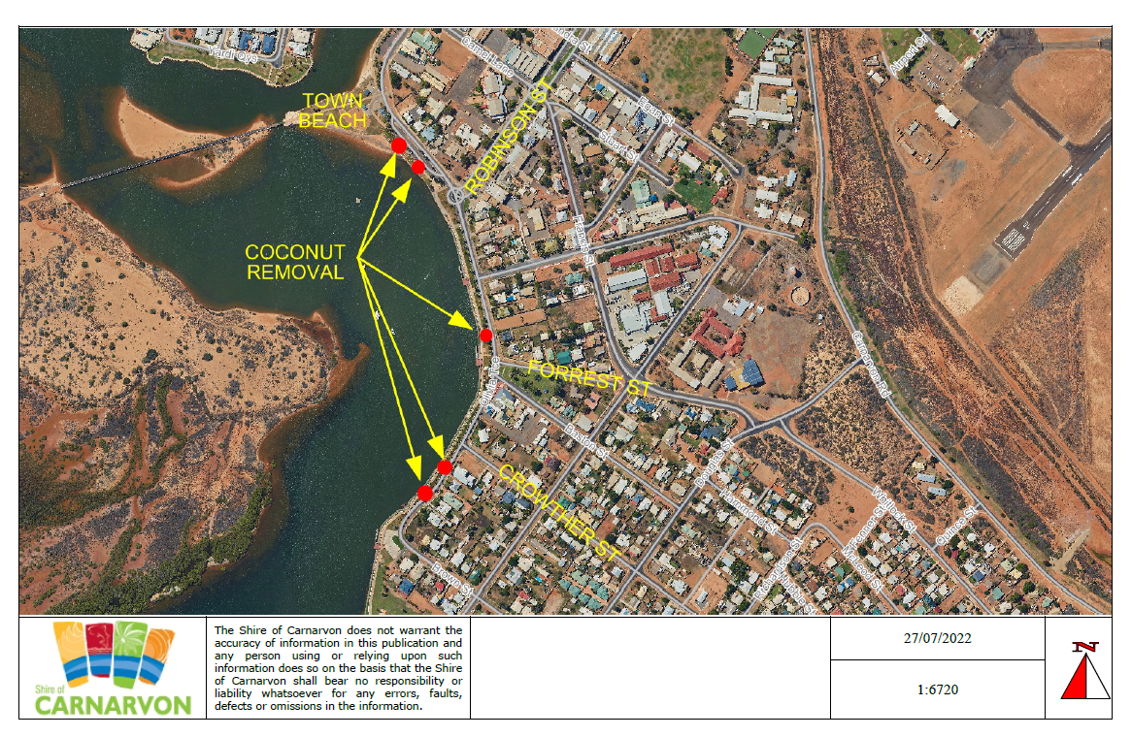

Andrea Selvey
CHIEF EXECUTIVE OFFICER

