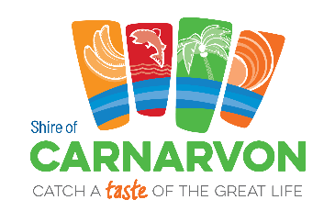
SHIRE OF CARNARVON
INVITATION TO SUBMIT TENDERS
#1 TENDER: RFT 02/2025 – TRAMWAY WALK TRAIL SHELTERS – CONSTRUCTION AND INSTALLATION
The Shire of Carnarvon is seeking the services of a qualified and experienced contractor to undertake the fabrication, construction and installation of two shelters (the Tramway Shelter and the Healing Shelter) and associated infrastructure along the Tramway Walk Trail, Carnarvon.
This project will improve the heritage value of the Tramway Walk Trail by improving the existing walk and enhancing storytelling along the route.

#2 TENDER: RFT 03/2025 – VAN DONGEN PARK STAGE ONE – LANDSCAPING AND CONSTRUCTION
The Shire of Carnarvon is seeking the services of a suitably experienced contractor to undertake landscaping and construction services, to deliver the Stage One upgrade of the Van Dongen Park, Carnarvon.
This project will see the development of a destination park focusing on iconic play equipment along with shaded areas with seating, landscaping and public art, for the enjoyment of the community and visitors.

The Tender documents and specifications for both tenders are available for download from www.tenderlink.com/carnarvon
Further information can be obtained by contacting Peta Greening, Senior Strategic Projects Manager via email greening.p@carnarvon.wa.gov.au.
Tenders must be submitted electronically via the Tenderlink portal. Tenders submitted via Facsimile or Electronic Mail will not be accepted
The deadline for Submissions is 10:00AM (WST) FRIDAY 12 DECEMBER 2025.
Canvassing of Councillors and Council staff will result in disqualification.

Amanda Dexter
CHIEF EXECUTIVE OFFICER

