THE HESTER COETSEE LAW WEEK ART COMPETITION 2026
ENTRY FORM and GUIDELINES

BACKGROUND INFORMATION
LAW WEEK runs from 16 to 22 May 2026.
It is a major community event held each year for the Western Australian community and the legal profession.
This is a chance to find out more about the law and our legal system and provides a unique opportunity to take the law outside of offices and courtrooms into the public.
Law Week is an occasion to help people see how the law affects them on a daily basis.
THE THEME
Regional Alliance West (“RAW”) is marking Law Week 2026 with an art competition with the theme “Law and the World Wide Web”.
Technology is everywhere, and it is not going away. Every day, more of our lives are being moved on-line and we can’t escape the rise of AI. The internet has a lot of benefits for us with ready access to information and services and being able to connect with others remotely. Social media has become a major part of how young people communicate, learn, and express themselves. But with that comes risks: cyberbullying, exposure to inappropriate content, and online predators, to name a few.
We don’t think about the everyday activity of using our phones, laptops or tablets as having something to do with the law but there are an ever-increasing number of laws that aim to keep us safe online.
The recent Social Media Minimum Age Law means that you must be 16 years or older to have a social media account.
There are laws that make image-based abuse a crime and that deal with issues such as identity theft, the use of facial recognition technology, cyber-bullying and stalking.
We have seen some recent high profile hacking situations with customer details stolen from large companies like Qantas, Optus and Medibank and many dollars lost to on-line scams.
Cybercrime is one of the fastest growing crime types in Australia and people can feel very nervous about the potential for their private and often sensitive information to become public through data breaches.
How have some of these laws affected you? Have you been kept safe online through some of these laws or have they caused you inconvenience?



THE COMPETITION

THEME: LAW AND THE WORLD WIDE WEB

REQUIREMENTS: An original work of art reflecting upon the theme

CLOSING DATE: 4:00 pm on Thursday 7 May 2026

AWARD CEREMONY: 3:30 pm on Thursday 21 May 2026
Geraldton Multipurpose Centre
CATEGORIES:

1. Junior Under 12 years old Prize: $750
Sponsored by Bundiyarra Aboriginal Community Aboriginal Corporation

2. Senior 12 to 17 years Prize: $1,000
Sponsored by

3. Open 18+ Prize: $1,500
Sponsored by

THE RULES

- Entrants must submit an original work of art (e.g. drawing, painting, sculpture) reflecting upon the theme, which can be in any medium, format or size.

- Entries must be submitted unsigned, without any marks identifying the artist and accompanied by a fully completed and signed Entry and Release Form. RAW staff will allocate a number to the entry form and match this to the reverse of the artwork so that judging can occur anonymously.

- Entries must be submitted to either of RAW’s Geraldton or Carnarvon offices by the closing date and time.

- Entrants must ordinarily reside in the Midwest, Murchison or Gascoyne regions.

- Entries will be judged on artistic appeal, originality and connection to the theme.

- The decision of the judges is final.

- Board members and staff of RAW and their immediate family members are ineligible to enter.

- Entrants must agree that if they are a category winner, RAW will retain their original artwork and RAW has the right to use their artwork however they see fit.

- If entrants would like their artwork returned to them at the conclusion of the competition, they must make these arrangements at their own expense.

- All entrants are welcome to attend the Awards Ceremony but must register to attend by contacting RAW prior to 15 May 2026.


ENTRY FORM

Full Name: ______________________________________________________________
Address: _____________________________________________________________
Phone: ______________________________________________________________
Email: ______________________________________________________________
Date of Birth: ______________________________________________________________

Category:
- Junior Under 12 years old (as at 7 May 2026)

- Senior 12 to 17 years (as at 7 May 2026)

- Open 18+

- I would like my artwork returned to me at the conclusion of the competition and understand that this will be at my own expense.

- I would like to attend the Awards Ceremony on 21 May 2026.

TITLE OF ARTWORK AND DESCRIPTION OF HOW IT RELATES TO THE THEME

TITLE: __________________________________________________________
DESCRIPTION: __________________________________________________________
__________________________________________________________
__________________________________________________________
__________________________________________________________
__________________________________________________________
__________________________________________________________
__________________________________________________________

TALENT RELEASE and CONSENT FORM

- I agree to take part in the Law Week Art Competition 2026.

- I understand and agree to the rules and conditions of the competition.

- If I am the winner of the category I have entered, I agree that Regional Alliance West may retain my original work of art and may use my artwork however they see fit including in brochures, advertisements, videos, photographs, media, websites, letterheads, and other promotional and marketing material and that I will not receive any fee for this use other than the prize money.

- I understand that RAW may take photographs or videos of my artwork and of me throughout the course of the competition and awards ceremony and I authorise / do not authorise [strike out one] the use of my video image and likeness and that of my artwork for the purposes of promoting RAW, Law Week and the Art Competition and that I will not receive any fee for this.

Signature of Entrant: _______________________________________________________

If under 18, Name of Guardian: _______________________________________________

Relationship of Guardian to the Entrant: _______________________________________

Signature of Guardian: _____________________________________________________
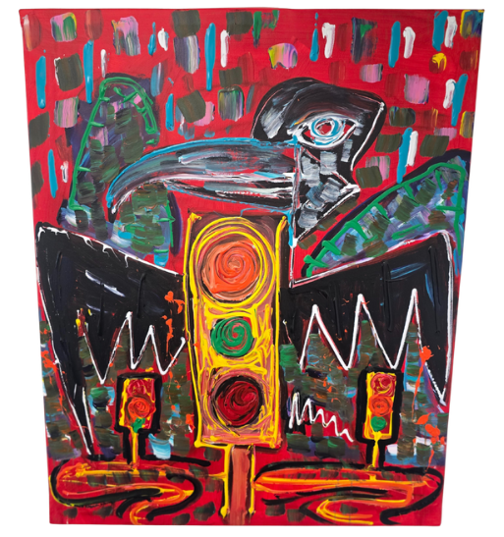
2025 Law Week Winner: Dustin Marshall “The Road Spectie”

