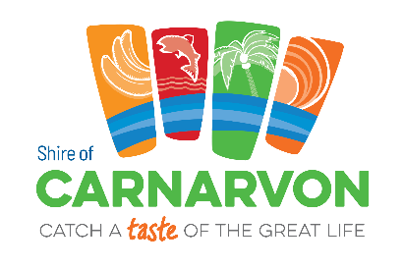
Shire of Carnarvon
Sporting, Fitness and Wellness Promotion
Terms and Conditions
These Terms and Conditions apply to all sporting clubs, fitness providers and wellness organisations submitting activities, programs or events for promotion by the Shire of Carnarvon.
By submitting information or creative assets, you agree to the following:
1. Eligibility
Submissions must relate to sporting, fitness or wellness activities delivered within the Shire of Carnarvon local government area.
2. Submission Requirements
Organisations must provide full and accurate details, including:
- Event or program name
- Location of activity
- Session run time (start and finish times)
- Event dates and duration
- Registration details (if applicable)
- Contact information
The submitting organisation is responsible for ensuring all information is correct at the time of submission and for notifying the Shire of any changes.
3. Creative Assets
Logos, posters and images must be supplied in high resolution format suitable for digital and print use.
A separate link may be issued via email for uploading creative assets, subject to approval.
By submitting creative assets, you confirm that:
- You own the material or have appropriate permission to use it
- Required consents have been obtained from identifiable individuals
- The Shire of Carnarvon is granted permission to use the material for promotional purposes across its communication channels
4. Review and Approval
All submissions are subject to review and approval by the Shire of Carnarvon.
The Shire reserves the right to:
- Edit content for clarity, formatting and brand consistency
- Decline or remove content deemed inappropriate, inaccurate or non-compliant
5. Promotion Channels
Approved activities may be promoted via:
- The Shire of Carnarvon website and Events Calendar
- Community newsletters
- Social media platforms
- Digital screens or other promotional channels
Inclusion is not guaranteed and is subject to available space, scheduling and communication priorities.
6. Responsibility and Liability
The Shire of Carnarvon is not responsible for the delivery, management or outcomes of any promoted activity.
Event organisers are solely responsible for:
- Event management and supervision
- Public liability insurance
- Risk management and safety compliance
- Registrations and participant communication
7. Amendments and Withdrawal
The Shire reserves the right to amend these Terms and Conditions at any time. Promotional content may be withdrawn at the Shire’s discretion.

